* IF

The first test must be an **if**. You can have as many **else if**s as you want, including zero.

You can include an else at the end, but you don’t have to have one

Java will test each case from the top to the bottom. When a condition is true, that block will be executed. After a block executes, Java skips down past the other cases. An else block executes when no other case has been true.

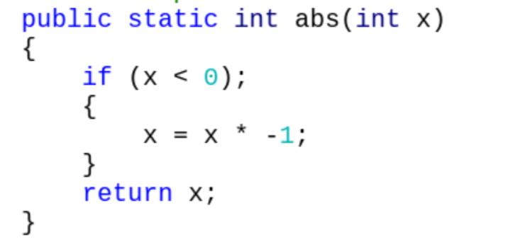 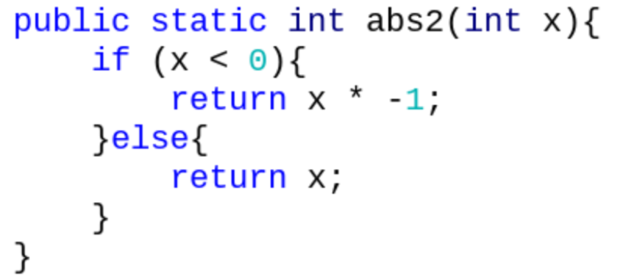 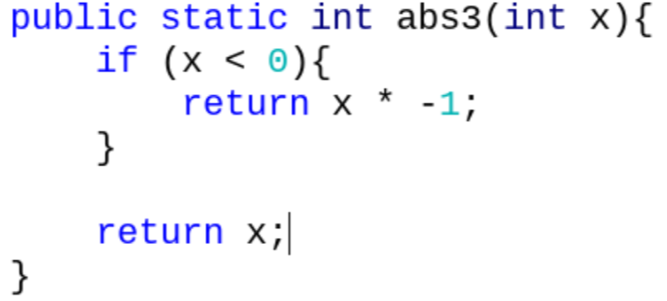

* NO semi-colon. **Either we add braces after a line of code, or a semi-colon, never both.**
* 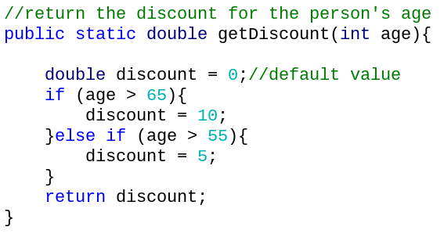SCOPE. **Variables only exist in the block (between the braces), where they are created.**

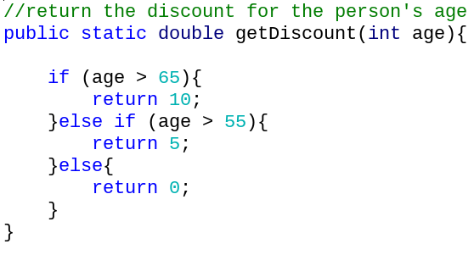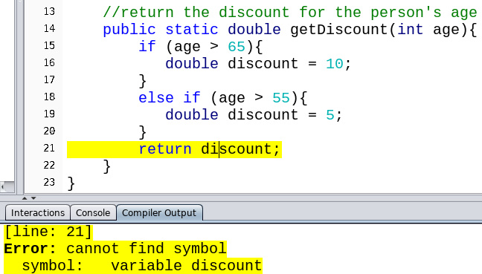

* AND

Symbol: **&& - The ampersand**

The result is true only if both of the boolean expressions on the sides are true.

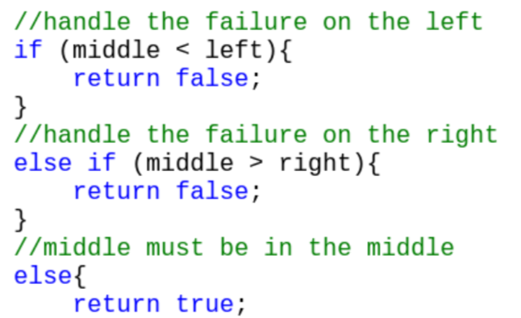Example: true && false is false

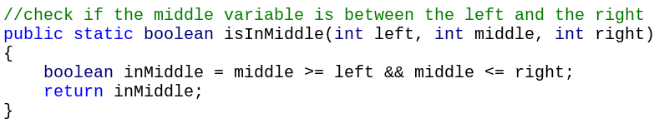

DON’T WRITE THIS:



* OR

Symbol: **|| - Vertical bar** - Found above the enter key

The result is true if either one of the boolean expressions on the sides is true.

Example: true || false is true

* NOT

Symbol: **!**

Gives the opposite boolean value.

Example: !true is false

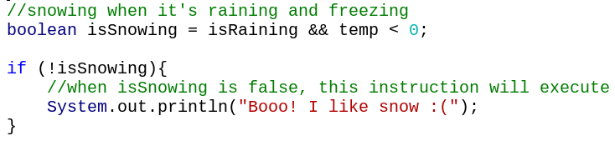

* Casting

*int* = **(int)** *double*----- **casting** the double value to the integer type (**throw away the decimal**).

* int num = (int) Math.random(); //always gives 0
* int num = (int) Math.random() * 20; //always gives 0

**Cast is applied to the Math.random() before the multiplication.**

int num= (int) (Math.random()*20); //gives 0-19 as an integer

* Integer conversions

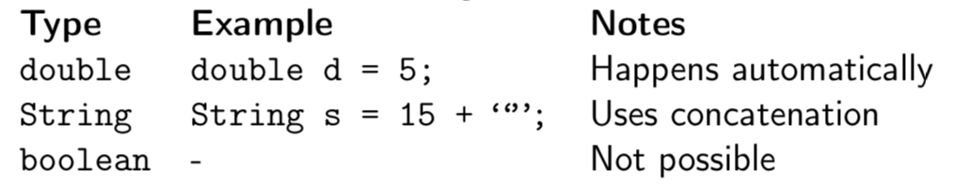

* Double conversions

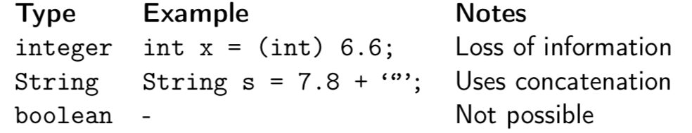

* String conversions

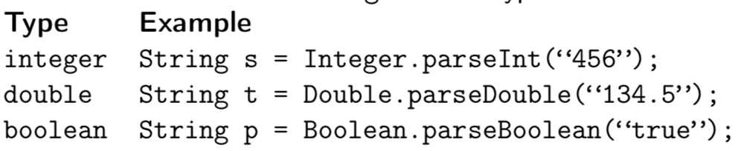

* Boolean conversions

